Software Requirement Specification Document
For
FUND FLOW

Table of Contents
Page Numbers
- Introduction 1.1 Purpose
  - Intended Customers/Users
  - Product Scope
  - Outline of the document
- Overall Description
  - Product Perspective
  - Product Functions
  - User Classes
  - Design and Implementation Constraints
- Diagrams
  - UML Diagrams
  - ER Diagrams
  - DFD Diagrams
  - Assumptions and Dependencies
- External Interface Requirements/Screenshots
  - User Interfaces
  - Hardware Interfaces
  - Software Interfaces
  - Communication Interfaces
- Other Non-Functional Requirements
  - Performance Requirements
  - Safety Requirements
  - Security Requirements
  - Software Quality Attributes
  - Business Policies/Rules (if any)
- Testing
  - Block-Box Testing
  - White-Box Testing
- Conclusion
- References
- Acknowledgements
SRS Draft: Investor-Entrepreneur Interface
Chapter I – Introduction
1.1 Purpose The purpose of this document is to define the software requirements for the FUNDFLOW platform. It describes the scope, primary features, and constraints of the system, serving as a roadmap for the development team and a reference for stakeholders.
1.2 Intended Customers / Users
- Entrepreneurs/Founders: Individuals or small business people seeking funding for their business ventures.
- Investors (Angel/VC): Individuals or firms looking for investment opportunities.
- System Administrators: Staff responsible for verifying users and managing the platform.
  - Product Scope This platform acts as a secure digital interface to join small business to stablished businesses . It will allow entrepreneurs to upload pitch decks and financial projections, while allowing investors to filter startups based on industry, stage, and funding requirements. The system's goal is to streamline the "discovery" phase of fundraising, though it may not handle the actual legal/financial transaction (unless you specify otherwise).
  - Outline of the Document This SRS is divided into several sections. Following this introduction, Chapter II provides a high-level overview of the product's perspective, main functions, and the constraints within which the software must operate. Later chapters (to be added) will cover specific functional and non-functional requirements.
Chapter II – Overall Description
  - Product Perspective The system is a web-based application. It operates as a centralized hub that replaces the fragmented process of cold-emailing and manual networking. It will integrate with cloud storage for document hosting and may use external APIs for user identity verification.
  - Product Functions (High-Level)
- User Registration & Profile Management: Separate onboarding flows for investors and founders.
- Pitch Management: Tools for founders to upload and update their business proposals.
- Search and Filter Engine: A robust tool for investors to find startups based on specific criteria (e.g., "FinTech," "Seed Stage").
- Messaging Interface: A secure channel for users to communicate once a match is made.
- Verification Dashboard: An admin tool to verify the legitimacy of businesses and accredited investors.
  - User Classes and Characteristics | User Class | Characteristics
Entrepreneurs | Likely tech-savvy; focused on presentation and ease of document upload. | | Investors | High-security requirements; value efficiency and "at-a-glance" data visualizations. | | Administrators | Technical users focused on data integrity and user moderation. |
  - Design and Implementation Constraints
- Data Security: Must comply with data protection regulations (like GDPR) because of sensitive financial info.
- Responsibility: The platform must be accessible across both desktop and mobile devices.
- Performance: The search engine must return results in under 2 seconds to ensure a professional user experience.
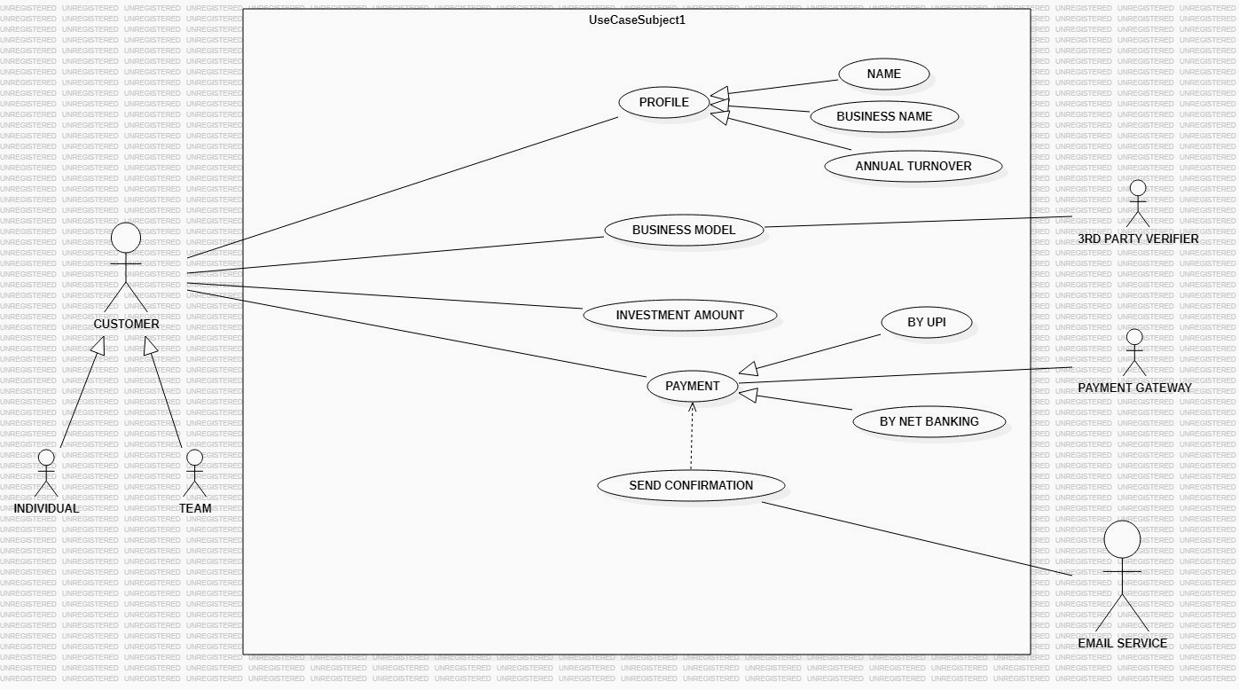
PRIMARY ACTORS:
    - CUSTOMER: This is the main user of the system, It plays the major role in this project.
    - PROFILE MANAGEMENT: Providing personal and personal details such as name, project details
    - DEFINING BUSINESS MODEL: Submitting or managing the specific business model for their venture.
    - SETTING INVESTMENT AMOUNT : Determining the financial figures for the investment.
    - MAKING PAYMENT : Determining the financial figures for the investment.
SUB ACTORS:
1) INDIVIDUAL AND TEAMS : These are specialized versions of the Customer. In UML, this "Generalization" relationship means that whether the user is a single person (Individual) or a group (Team), they both perform all the actions attributed to the primary "Customer" actor.
SUPPORTING ACTORS:
    - 3_{rd} PARTY VERIFIER : The actors are responsible for supporting the busniness model. role likely involves validating the business plan or conducting due diligence on the proposal submitted by the customer.
    - PAYMENT GATEWAY : This service manages the actual processing of the payment. It shows payment can be done by UPI or NET BANKING.
    - EMAIL SERVICE : IT handels the send confirmation use case.

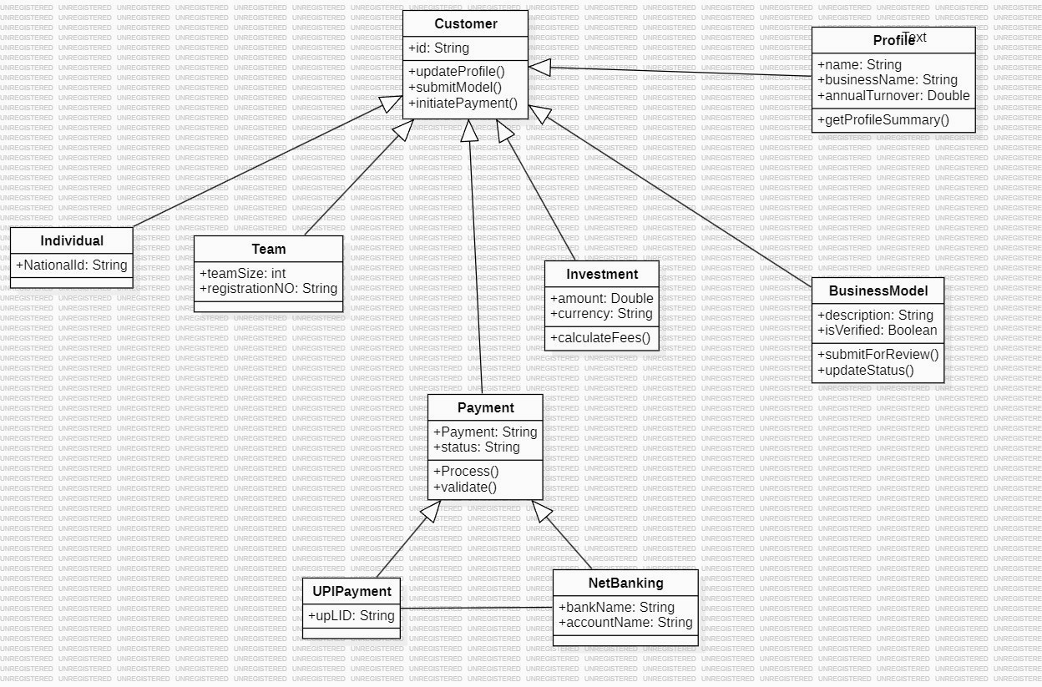
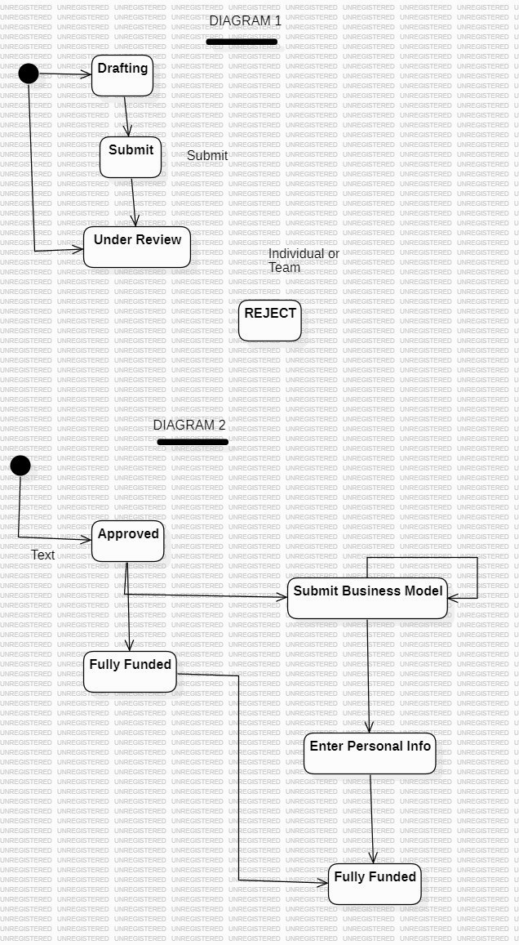
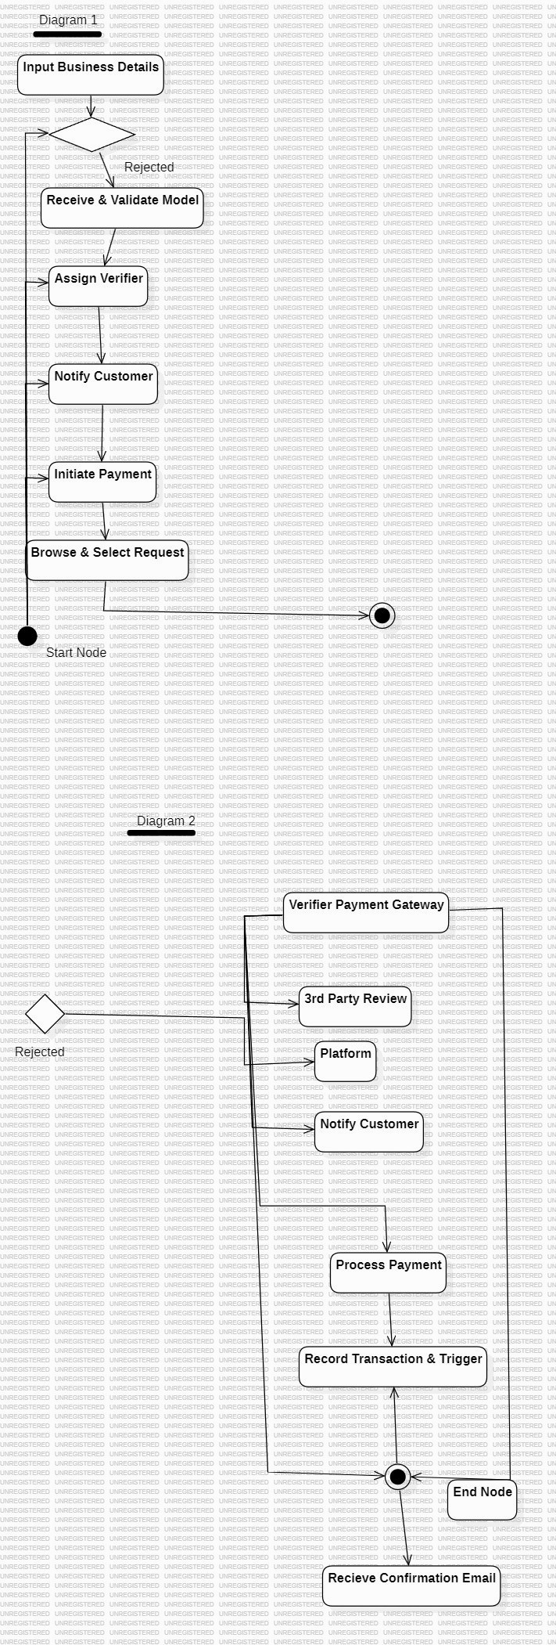
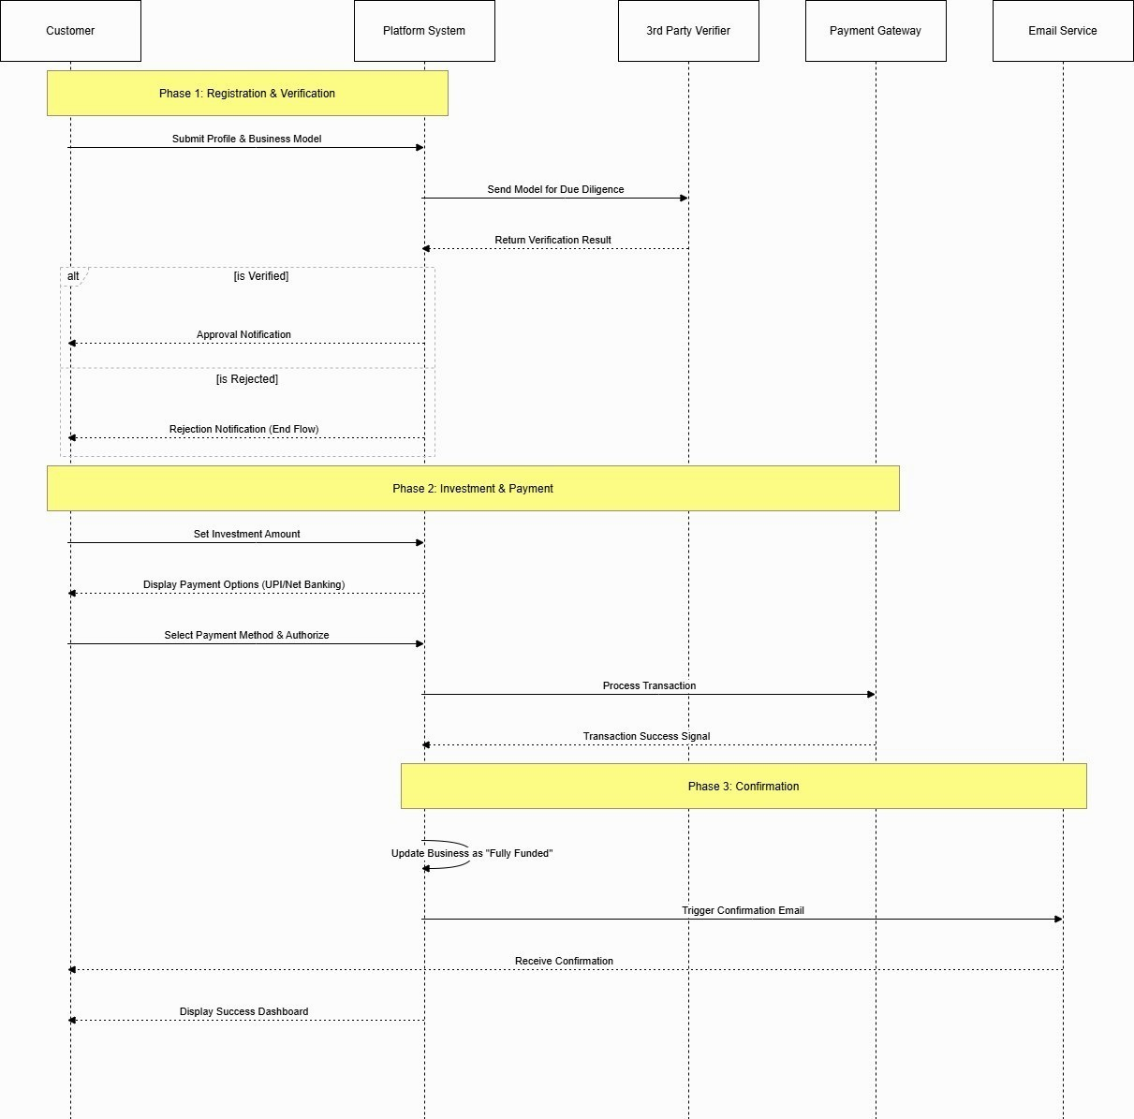

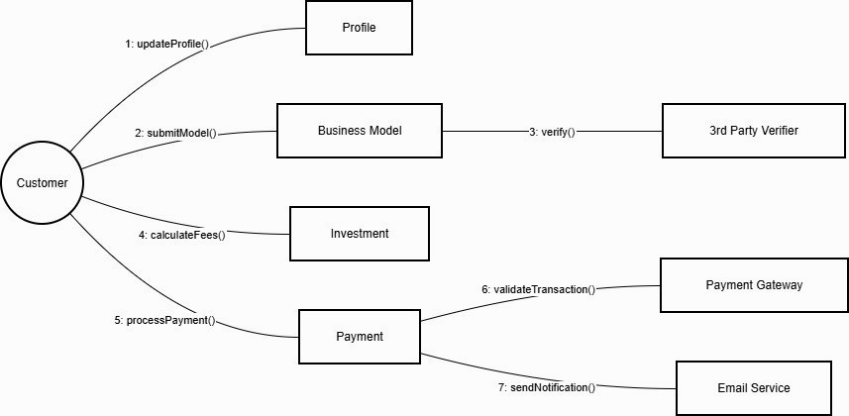
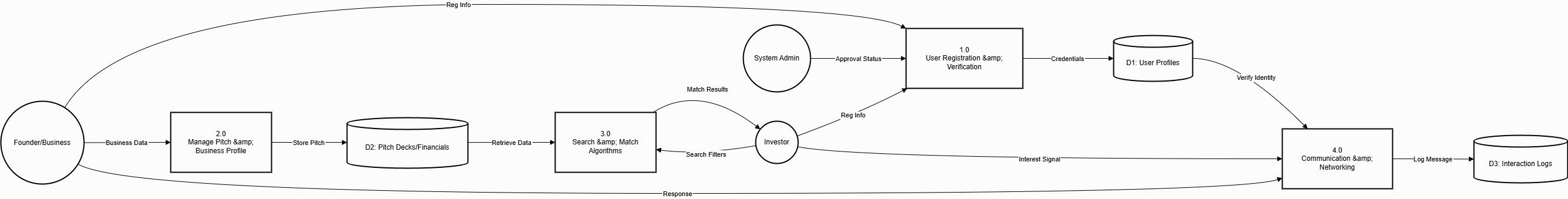
Design and Implementation Constraints
Building a bridge for financial investments comes with some "real-world" rules we have to follow:
The Trust Factor (Security): Because we are handling "un-patented" business ideas, we cannot afford a data leak. If a founder’s secret sauce is leaked, our platform fails. This means high-level encryption is a must, not an option.
The "Mobile-First" Reality: Investors are often on the move. While founders will likely upload their pitches from a laptop, investors will probably browse them on their phones between meetings. Our design must work perfectly on both.
Legal Compliance: We aren't just building a website; we’re building a financial tool. We have to ensure our "verification" process is strong enough to keep out scammers or fake businesses.
- Non-Functional Requirements (The "Vibe" of the App)
Safety (Security): Think of the app like a digital vault. We use Multi-Factor Authentication (MFA) so that even if a password is stolen, a founder’s pitch deck stays safe.
Speed (Performance): No one waits for a slow website anymore. If an investor hits "search," the results need to pop up in under 2 seconds, or they’ll likely close the tab.
Reliability: The platform needs to be up 24/7. Investment opportunities don’t wait for office hours, so the system shouldn't have "downtime."
- External Interfaces (How it talks to the world)
The User Experience (UI): We want the founder's side to feel like a supportive workspace and the investor's side to feel like a high-end financial dashboard.
The "Paperwork" (Software Interfaces): We’ll plug into services like Stripe for any payments and AWS to store those heavy PDF pitch decks securely.
Staying in the Loop (Communications): The app will send real-time alerts. If an investor likes a business, the founder should get a text or email immediately so they can jump on the opportunity.
White box texting

CODE 1
def login(email, password): stored_email
= "investor@fundflow.com" stored_password = "fund123"
if email == stored_email and password == stored_password:
return "Login Successful" else:
return "Invalid Email or Password" # Example print(login("investor@fundflow.com", "fund123")) FLOW GRAPH:
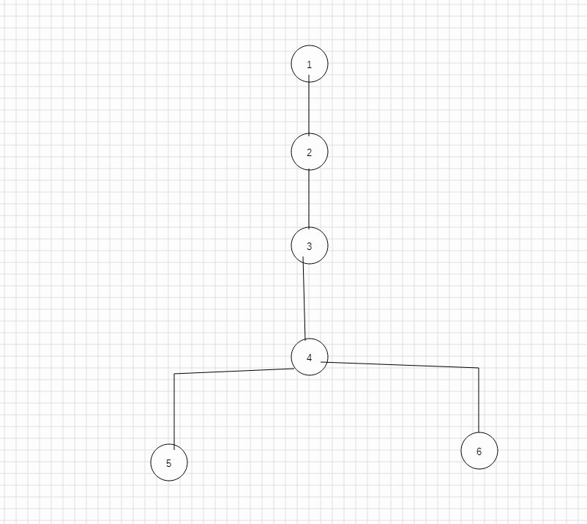

Cyclomatic Complexity Calculation
The given flow graph contains the following nodes and edges.
Nodes in the graph:
1, 2, 3, 4, 5, 6
Total number of nodes (N) = 6 Edges in the graph:
- → 2
- → 3
- → 4
- → 5
4 → 6
Total number of edges (E) = 5
Number of connected components (P) = 1
The formula used to calculate Cyclomatic Complexity is:
V(G) = E - N + 2P Substituting the values:
V(G) = 5 − 6 + 2(1)
V(G) = 1
However, in a proper flow graph both nodes 5 and 6 should connect to an End node.
After adding the End node:
Total nodes = 7
Total edges = 7
Cyclomatic Complexity:
V(G) = 7 − 7 + 2(1) V(G) = 2
Therefore, the Cyclomatic Complexity of the program is 2.
Independent Paths:
Path 1: 1 → 2 → 3 → 4 → 5 → End
Path 2: 1 → 2 → 3 → 4 → 6 → End
Thus, the program has 2 independent paths.

TESTING CODE
def login(email, password): stored_email
= "investor@fundflow.com" stored_password = "fund123" if email == stored_email and password == stored_password: return "Login Successful" else: return "Invalid Email or Password"
# Test Cases for Black Box Testing
print("Test Case 1:", login("investor@fundflow.com",
"fund123")) # Correct email and password print("Test
Case 2:", login("investor@fundflow.com",
"wrong123")) # Wrong password print("Test Case 3:", login("wrong@mail.com", "fund123"))
# Wrong email
print("Test Case 4:", login("", "")) # Empty input

OUTPUT
Test Case 1: Login Successful
Test Case 2: Invalid Email or Password
Test Case 3: Invalid Email or Password
Test Case 4: Invalid Email or Password
CODE 2:
def process_investment(amount, payment_method):

if amount <= 0: return "Invalid Investment
Amount"
# Calculate platform fee if amount <= 10000: fee = amount * 0.02 elif amount <= 50000:
fee = amount *
0.015 else: fee = amount
* 0.01 total_amount = amount + fee
# Payment method checking if payment_method == "UPI":
return "Payment Successful through UPI. Total Paid: " + str(total_amount)
elifpayment_method == "NETBANKING":
return "Payment Successful through Net Banking. Total Paid: " + str(total_amount)
else:
return "Payment Method Not Supported"
# Example Test Runs print(process_investment(5000,
"UPI")) print(process_investment(20000,
"NETBANKING"))
print(process_investment(80000, "UPI")) print(process_investment(-100, "UPI")) print(process_investment(10000, "CARD"))
FLOW CHART:
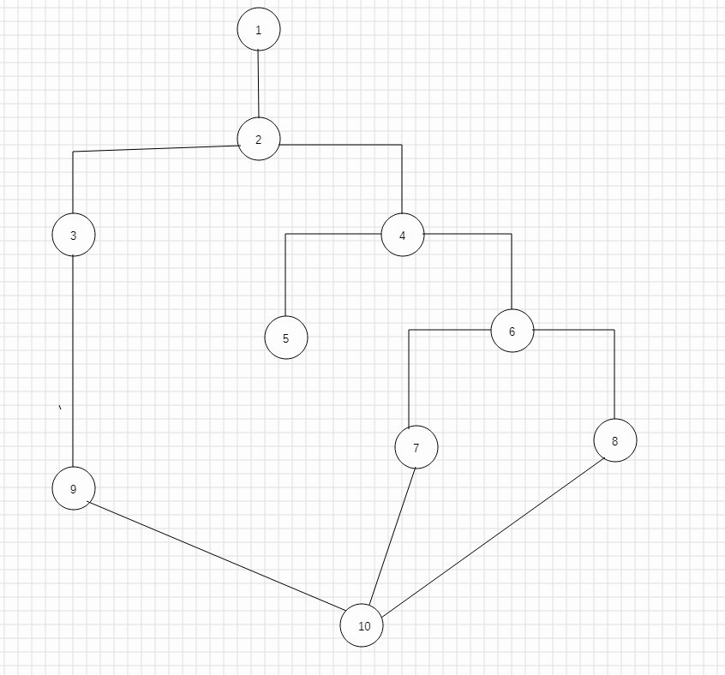

Cyclomatic Complexity Calculation
Cyclomatic Complexity Calculation We use the formula:
V(G) = E - N + 2P
Where
E = Number of edges
N = Number of nodes
P = Number of connected components
Number of nodes (N) = 11
Number of edges (E) = 14
Number of connected components (P) = 1 Substituting values:
V(G) = 14 − 11 + 2(1)
V(G) = 5
Cyclomatic Complexity = 5
Independent Paths
Path 1
Start → amount ≤ 0 → End
Path 2
Start → amount > 0 → amount ≤ 10000 → UPI → End
Path 3
Start → amount > 0 → amount ≤ 10000 → NETBANKING
→ End
Path 4
Start → amount > 0 → amount ≤ 50000 → UPI → End
Path 5
Start → amount > 0 → amount > 50000 → Payment not supported → End
TESTING CODE
def process_investment(amount, payment_method):
if amount <= 0: return "Invalid Investment
Amount"
if amount <= 10000: fee = amount * 0.02 elif amount
<= 50000: fee = amount *
0.015 else: fee = amount
* 0.01 total_amount = amount
+ fee if payment_method ==
"UPI": return "Payment
Successful through UPI. Total Paid: " + str(total_amount)
elifpayment_method == "NETBANKING":
return "Payment Successful through Net Banking. Total
Paid: " + str(total_amount)
else:
return "Payment Method Not Supported"
# Test Cases
print("Test Case 1:", process_investment(-100, "UPI")) print("Test Case 2:", process_investment(5000, "UPI")) print("Test Case 3:", process_investment(20000,
"NETBANKING"))
print("Test Case 4:", process_investment(80000, "UPI")) print("Test Case 5:", process_investment(15000, "CARD"))
OUTPUT
Test Case 1: Invalid Investment Amount
Test Case 2: Payment Successful through UPI. Total Paid: 5100.0
Test Case 3: Payment Successful through Net Banking. Total Paid: 20300.0
Test Case 4: Payment Successful through UPI. Total Paid: 80800.0
Test Case 5: Payment Method Not Supported
BLACK BOX TESTING
CODE 1:-

STEP 1(FUNCTIONAL REQUIREMENT)
Functional Requirements for Black Box Testing
- The system should allow a user to log in using their registered email and password.
- The system should check whether the email entered by the user exists in the system.
- The system should verify that the password entered by the user matches the stored password.
- If the user enters an incorrect email or password, the system should display an error message such as "Invalid Email or Password".
- The system should not allow login if the email or password fields are left empty.
- When the correct email and password are entered, the system should allow the user to log in successfully.
- The system should ensure that only authorized users can access the application after login

STEP 2( EQUIVALENCE PARTITIONING)
Equivalence Partitioning is a black box testing technique where the input values are divided into different groups. Each group is called an equivalence class. The idea is that all values within a group behave in a similar way, so instead of testing every possible value, we test one value from each group.
For the Investment and Payment Processing System, the inputs such as investment amount and payment method can be divided into logical groups.
For Investment Amount
Valid /
Class Range
Invalid
EC1 Amount ≤ 0 Invalid
EC2 1 – 10000 Valid
EC3 10001 – 50000 Valid Amount >
EC4 Valid
50000 Explanation:
If the investment amount is zero or negative, the system should reject it. Any positive amount within the defined ranges is considered valid and will be processed by the system.
For Payment Method
Valid /
Class Input | Invalid
EC5 UPI | Valid
EC6 NETBANKING  Any other payment | Valid
Invalid
EC7 method
Explanation:
The system currently supports UPI and Net Banking as valid payment methods. If the user enters any other method such as card or cash, the system should display an error message. Example Test Inputs
Class Example Input Expected Result
EC1 | -100 | Invalid investment amount
EC2 | 5000 | Process investment with fee
EC3 | 20000 | Process investment with fee
EC4 | 80000 | Process investment with fee
EC5 | UPI | Payment successful
EC6 | NETBANKING | Payment successful
EC7 | CARD | Payment method not
supported

STEP 3

BB Test Input
Expected Output Technique No (Amount)
Invalid Investment 0 −
BB1 -1
Amount 1
Invalid Investment
BB2 0 0
Amount
BB3 1 Investment Accepted 0 +
1

STEP 4 CODE
1:
def login(email, password): stored_email
= "investor@fundflow.com" stored_password = "fund123" if email == stored_email and password == stored_password:
return "Login Successful" else: return "Invalid Email or
Password"
# Example
print(login("investor@fundflow.com", "fund123"))

SAMPLES INPUT
print(login("investor@fundflow.com", "fund123")) print(login("investor@fundflow.com", "wrong123")) print(login("wrong@mail.com", "fund123")) print(login("",
""))

CODE 2 STEP 1(FUNCTIONAL REQUIRENMENT)
Entering Investment Amount
The system should allow the user to enter the amount they want to invest in a project.
Checking the Investment Amount
The system should check whether the entered investment amount is valid. If the amount is zero or negative, the system should show the message “Invalid Investment Amount.”
Calculating Platform Fee
The system should automatically calculate a platform fee based on the investment amount entered by the user.
Fee for Small Investments
If the investment amount is 10,000 or less, the system should apply a 2% platform fee.
Fee for Medium Investments
If the investment amount is between 10,001 and 50,000, the system should apply a 1.5% platform fee.
Fee for Large Investments
If the investment amount is greater than 50,000, the system should apply a 1% platform fee.
Total Amount Calculation
The system should calculate the total payment amount by adding the investment amount and the calculated platform fee.
Selecting Payment Method
The system should allow the user to choose a payment method such as UPI or Net Banking.
Successful Payment Message
If the payment method is valid, the system should display a successful payment message along with the total amount paid.
Invalid Payment Method Handling
If the user enters a payment method that is not supported by the system, the system should display “Payment Method Not Supported.”
STEP 2(EQUIVALENCE PARTITIONING)

Investment Amount Partitions
Input Example Test
Class |  | Type |  | Expected Result
 | Range |  | Value
EC1 | Amount ≤  0 | Invalid | -100 | Invalid Investment  Amount
EC2 | 1 – 10000 | Valid | 5000 | Fee = 2%
EC3 | 10001 –  50000 | Valid | 20000 | Fee = 1.5%
EC4 | > 50000 | Valid | 80000 | Fee = 1%

Payment Method Partitions
Example Test  Class Input Type  Value | Expected  Result
EC5 UPI Valid UPI | Payment Successful
EC6 NETBANKING Valid NETBANKING | Payment Successful
Any other  EC7 Invalid CARD  method  STEP 3  Boundary at 0 (Minimum Investment  BB Test Input | Payment  Method Not  Supported
Expected Output
No (Amount) | Technique
Invalid Investment
BB1 -1 0 − 1
Amount
Invalid Investment
BB2 0 0
Amount
Valid investment (Fee
BB3 1 0 + 1
calculation starts)

Boundary at 10000 (Fee Change Point)
BB NoTest Input (Amount)Expected OutputTechnique
BB4 9999 Fee = 2% 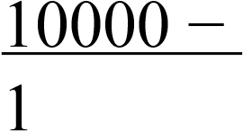
BB5 | 10000 | Fee = 2% | 10000
BB6 | 10001 | Fee = 1.5% | 10000 + 1

STEP 4: CODE
2
def process_investment(amount, payment_method):

if amount <= 0: return "Invalid Investment
Amount"
# Calculate platform fee if amount <= 10000: fee = amount
* 0.02 elif amount
<= 50000: fee = amount *
0.015 else: fee = amount * 0.01 total_amount = amount + fee
# Payment method checking if payment_method == "UPI":
return "Payment Successful through UPI. Total Paid: " + str(total_amount)
elifpayment_method == "NETBANKING":
return "Payment Successful through Net Banking. Total Paid: " + str(total_amount)
else:
return "Payment Method Not Supported"

SAMPLE INPUTS
print(process_investment(5000, "UPI")) print(process_investment(20000, "NETBANKING")) print(process_investment(80000, "UPI")) print(process_investment(-100, "UPI")) print(process_investment(10000, "CARD")) print(process_investment(0, "UPI")) print(process_investment(50000, "NETBANKING")) DESIGN ARCHITECTURE OF SYSTEM COMPONENT LEVEL DESIGN:
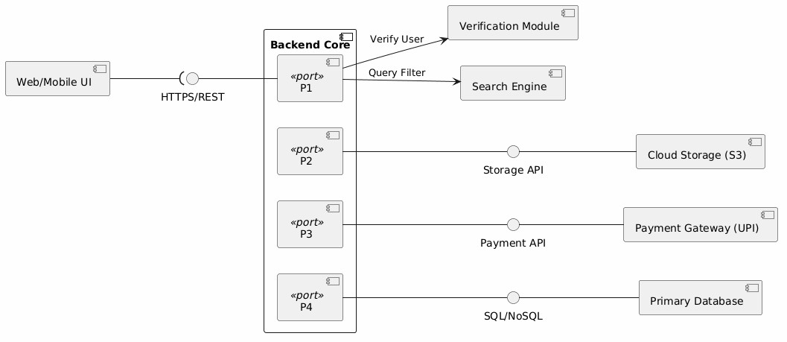
DEPLOYMENT LEVEL DESIGN:
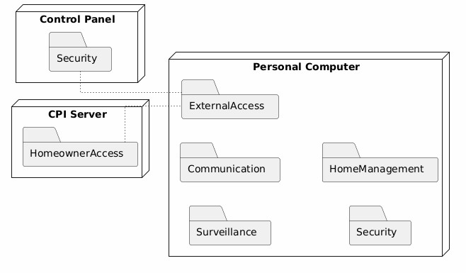
Metrics for Analysis Model
Calculating Function Point Analysis
It consists of 5 domains:
- Number of External Input (EIs)-
Input provided by the user or another application. E.g. Logical order or forms.
- Number of External Output (EOs)-
Data from the system that provides information to the user. E.g. Bills, reports.
- Number of External queries (EQs) E.g. Search products.
- Number of Internal Logical Files (ILFs)-
Internal database that is within the application's boundary. E.g. Customer database.
- Number of External Interface Files (EIFs)-
The external database is external to the application’s boundary.
E.g. Data used from other systems.
Formula:
Calculate Count total or UFP (Unadjusted Function Point)
Component | Count Complexity Weight | Total
External Inputs (EI) | 5 Average 4 | 5 × 4 =  20
External Outputs (EO) | 4 Average 5 | 4 × 5 =  20
External Queries (EQ) | 3 Average 4 | 3 × 4 =  12
Internal Logical Files | 4 Average 10 | 4 × 10 =
(ILF) 40
External Interface Files
2 × 7 =
2 Average 7
(EIF) 14
Total = Sum of all values
UFP = 20 + 20 + 12 + 40 + 14 = 106
Scale:
0 = Not important
5 = Very important
No Factor Description Rating
Uses internet (web
- Data Communications 4
app)
- Distributed Processing Cloud + APIs 3
- Performance Fast search (<2 sec) 5
Heavily Used
- Many users 4
Configuration
- Transaction Rate Moderate transactions 3
- Online Data Entry Users input data 5
- End-user Efficiency UI must be smooth 4
- Online Update Real-time updates 4
- Complex Processing Payment + filtering 4
- Reusability Moderate reuse 3
- Installation Ease Web-based (easy) 4
- Operational Ease Easy to use 4
- Multiple Sites Accessible anywhere 4
Future updates
- Facilitate Change 4
possible
1)ΣFi = 4+3+5+4+3+5+4+4+4+3+4+4+4+4 = 55

CALCULATE CAF
CAF=0.65+(0.01×ΣFi)

CAF=0.65+(0.01×55)
CAF=0.65+0.55=1.20

3)CALCULATE FINAL FP
Formula:
CAF = 1.20
Final Function Points (FP) = 127

Assume Standard Values
1 FP = 10 hours (standard assumption) Cost per hour = ₹400

Calculate Development Hours
Hours=FP×hours per FP
Hours=127×10=1270 hour

Calculate Project Cost
Cost=Hours×Cost per hour
Cost= 1270*400=508000
Metric Value
Function Points (FP) 127
Development Hours 1270 hours
Cost per Hour ₹400
Total Cost ₹5,08,000

EMPIRICAL ESTIMATION MODELS

COCOMO MODEL

Boehm’s categorizes the projects:

i. Organic - If the team size required to develop a software
project is small.
ii. Semi-detached – if team size, experience and knowledge
lies in between organic and embedded.
iii. Embedded - require the highest level of complexity and
experience along with large team size.

COCOMO model (Constructive cost model) is a regression
based model, proposed by Barry Boehm used for predicting the
various parameters associated with development of a project.

There are three types of COCOMO models:

1. Basic COCOMO Model
2. Intermediate COCOMO Model
3. Detailed COCOMO Model

- BASIC COCOMO MODEL

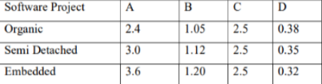

LOC = 12.7 KLOC
Therefore, Estimated size of project = 12.7-KLOC.
It is an organic mode of project.

Effort (E) = A*(KLOC)^B
= 2.4* (12.7) ^1.05
= 34.61 Person- Month

Time (T) = C*(Effort)^D
= 2.5* (34.61) ^0.38
= 9.61 months

- Intermediate COCOMO Model
Cost Drivers Number | Very Low | Low | normal | high | Very high | Extra high
1 |  |  |  | 1.15
2 |  |  | 1.0
3 |  |  | 1.0
4 |  |  |  |  | 1.30
5 |  |  | 1.0
6 |  | 0.87
7 |  |  |  | 1.07
8 |  |  | 1.0
9 |  |  |  | 0.91
10 |  |  |  | 0.86
11 |  |  |  | 0.9
12 |  |  | 1.0
13 |  |  |  |  | 0.82
14 |  |  |  |  | 0.83
15 |  |  | 1.0

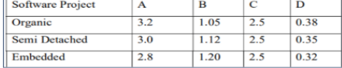

EAF (Product of cost drivers) = 0.66

Effort ( E ) = (A*(KLOC)^B ) * EAF
= 3.2*(12.7) ^1.05 * 1.12
= 51.68

Time (T) = C*(Effort)^D
= 2.5*(51.68) ^0.38
= 11.16 MONTHS

Persons required = Effort / Time
= 51.68/11.16
= 4.63 Persons

